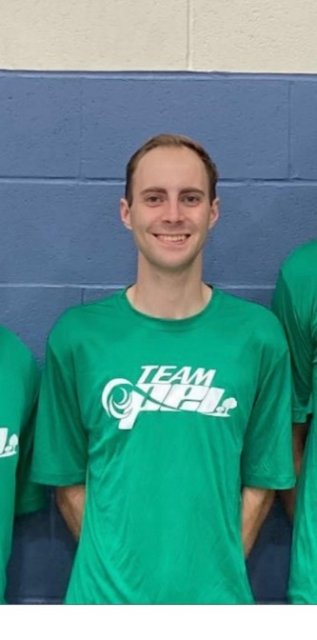
Max Arsenault – Head Coach 2025 Canada Games Men’s Indoor Volleyball
Max grew up in Fredericton, NB and played for many of the top club and provincial teams in New Brunswick before embarking on his college playing career at Holland College. Throughout his five-year playing career Max collected many individual accolades including being named the Libero of the Year within the ACAA and was also a member of many successful Hurricanes teams in his time at the college
After his playing career ended Max jumped right into coaching at the College and High School level with the Colonel Gray Colonels and his alma mater, the Holland Hurricanes, where his teams had many successes under his watch. Max has also been one of the lead provincial team coaches with Volleyball PEI on the men’s side and has coached our 18U and 16U teams at many Club, Eastern Elite and Canada Cup competitions over the last number of years. Highlights include winning a gold medal at Club Nationals with his Inferno Club, many top three finishes at Eastern Elites, and a very successful stint as our 2022 Men’s Indoor Canada Games Indoor Volleyball team in Niagara, ON.
Max has dedication like no other. He is always on top of his preparation including getting to the gym an hour before or staying an hour after practice helping his athletes with certain skills that they want to improve upon. Max is keen to continue building on the success of past Volleyball PEI coaches and will go to all ends of our province to see and encourage our next generation of men’s volleyball players aspire to the next level.
Max has also taught his athletes that there are much bigger and more important things than the game being played. He always makes sure that his teams are well involved in the community such as doing participating in filling up the community fridge and helping raise money for breast cancer whilst also participating in run for the cure. Max is also a certified Learning Facilitator in PEI and delivers the Development Coach Workshop for the NCCP ensure the pipeline of coaches in PEI continues for years to come.
Please help Volleyball PEI welcome Max Arsenault back behind the bench of our 2025 Canada Games Men’s Indoor Volleyball team!

