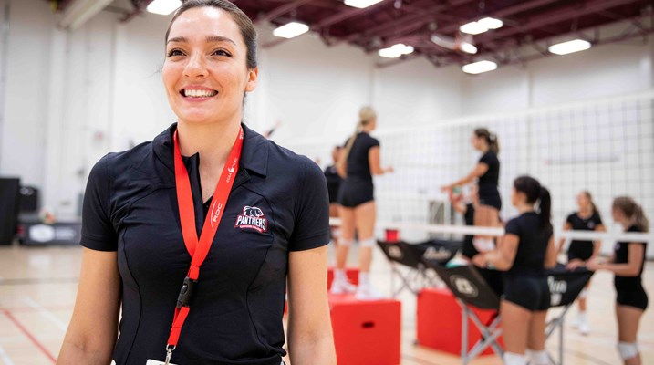

Alice Champion – Head Coach 2025 Canada Games Women’s Indoor Volleyball

Born in Rio de Janeiro, Alice Champion has played as a volleyball player in Brazil, USA, and Canada. She has played at some of the highest levels of volleyball throughout her young adult years, from clubs like Bradesco in Brazil, moving to United States to play in the NCAA, before finishing her playing career as a member of the Holland Hurricanes.

Since 2017, Alice has been coaching volleyball in Prince Edward Island at the College, Provincial Team and High School level bringing multiple wins along the way at the ACAA Championships, the Canada Cup, Club Nationals, and at the 2022 Canada Summer Games in Niagara, ON.

In the summer of 2022, Alice moved her young family from PEI to North Bay to begin her work as Head Coach of the Canadore College Women's Varsity Volleyball team, bringing her focus on mental health, teamwork, and professionalism to the court.

Alice's exposure to different coaching philosophies over her career extends both on and off the court, from strengthening exercises to emotional sharing circles. "Volleyball gave me everything that I have in life," says Alice. "I want to give back to the sport, and help my athletes win both on and off the court."

When the 2023-2024 college season ends in March for Canador, Alice will move back to PEI to begin working with her coaching staff (Assistant Coaches to be hired soon!) on the athlete selection process for our 2024 provincial teams. At the conclusion of the 2024 summer provincial team season, she will head back to Canador College to continue in her leadership role there, while maintaining contact with the training team athletes as they compete for their own college or high school teams and work on their strength & conditioning and mental training programs leading up to the final team selection for the Canada Games in the summer 2025.

Please join Volleyball PEI as we welcome Alice back into the Volleyball PEI fold, as Head Coach of our Women’s Indoor Volleyball team for the 2025 Canada Games in St. John’s, NL!

